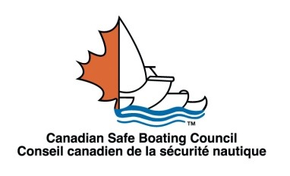

**How Do I Join the Canadian Safe Boating Council?**

**MEMBERSHIP CATEGORIES**

Please choose one.

INDIVIDUAL $ 75

GROUP $250

Fees are annual for the calendar year.

DISTRIBUTION list only

Check here

CHARGE CARD PAYMENT:

By VISA, MasterCard or Amex

Card Payment is done through [www.csbc.ca](http://www.csbc.ca/) on the CSBC Membership – Charge Card Payment Page.

CHEQUE PAYMENT:

Payable to **CSBC**

Cheque enclosed $ ______

INVOICE US

If you require an invoice, please email completed form to:

[treasurer@csbc.ca](mailto:treasurer@csbc.ca)

**GROUP or PATRON ORGANIZATION NAME**

This isas you wish it listed in the membership directory:

Organization Name**:**

Website: www.

**VOTING MEMBER'S NAME** and mailing address:

Name:

Organization Name:

Address line 1:

Address line 2:

City:

Province:

Postal Code:

Phone 1:

Phone 2:

Email (required):

**1**French Language preference

Who recommended you join CSBC _______________________

Please email any questions to: [membership@csbc.ca](mailto:membership@csbc.ca)

Please email this completed form to: [membership@csbc.ca](mailto:membership@csbc.ca) or mail form to the address below.

**Thank you for supporting the Canadian Safe Boating Council with your membership**

Send cheque payment to: **CSBC, 400 Consumers Road, Toronto, ON M2J 1P8**